M2 PROJECT REPORT
RIDHAM MAHAJAN

Abstract
This project explores regression techniques to predict bike rental demand using the Bike Sharing dataset. Three models were implemented: simple linear regression, multiple linear regression, and polynomial (nonlinear) regression. Each approach was evaluated using metrics such as R-squared and Mean Squared Error (MSE). The comparison highlights how incorporating additional features and nonlinear transformations improves predictive accuracy.

1. Introduction
Bike-sharing systems have become an essential part of urban mobility. Predicting rental demand helps operators manage resources efficiently. In this project, I analyzed the Bike Sharing dataset (Washington, D.C.) to understand how weather and environmental factors influence bike usage. The dataset includes hourly and daily rental counts along with features like temperature, humidity, windspeed, and weather conditions. The target variable is the rental count (cnt).
The study is divided into three tasks:
- Task 1: Simple linear regression using temperature.
- Task 2: Multiple linear regression with additional predictors.
- Task 3: Nonlinear regression using polynomial features.

2. Tasks
Task 1: Simple Linear Regression
- Step 1: Loaded dataset into Pandas and plotted temp vs count.
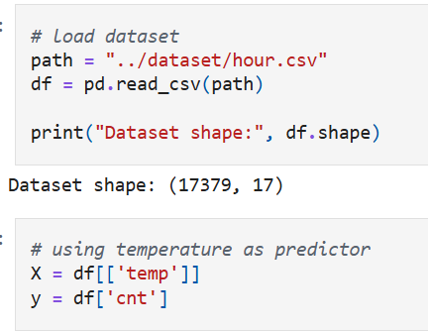
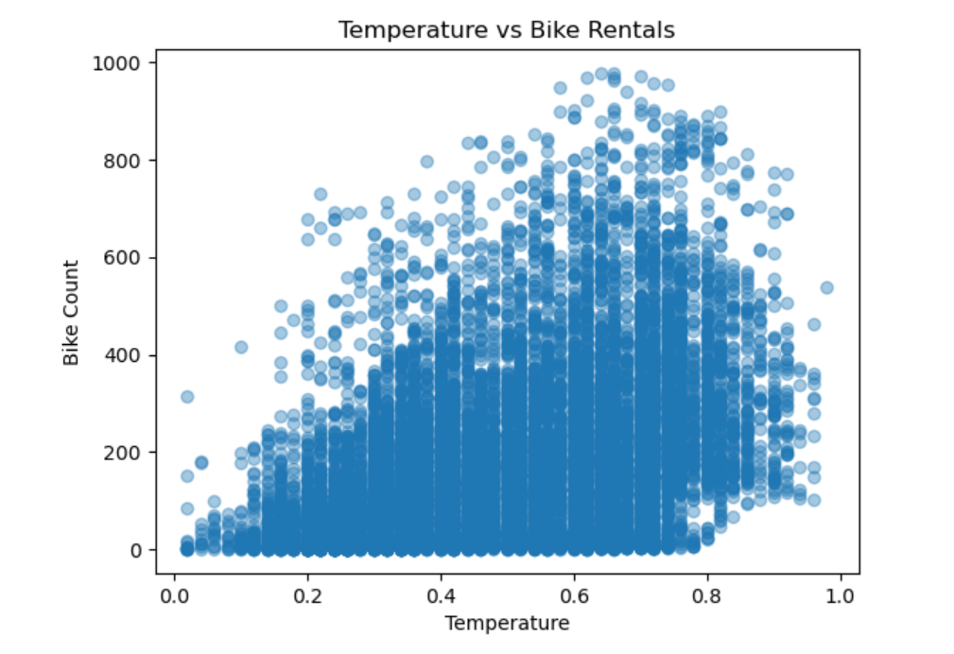

- Step 2: Fitted a simple linear regression model with temp as predictor.
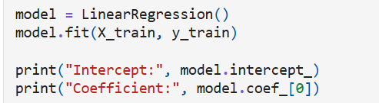
- Step 3: Plotted regression line and calculated R-squared.
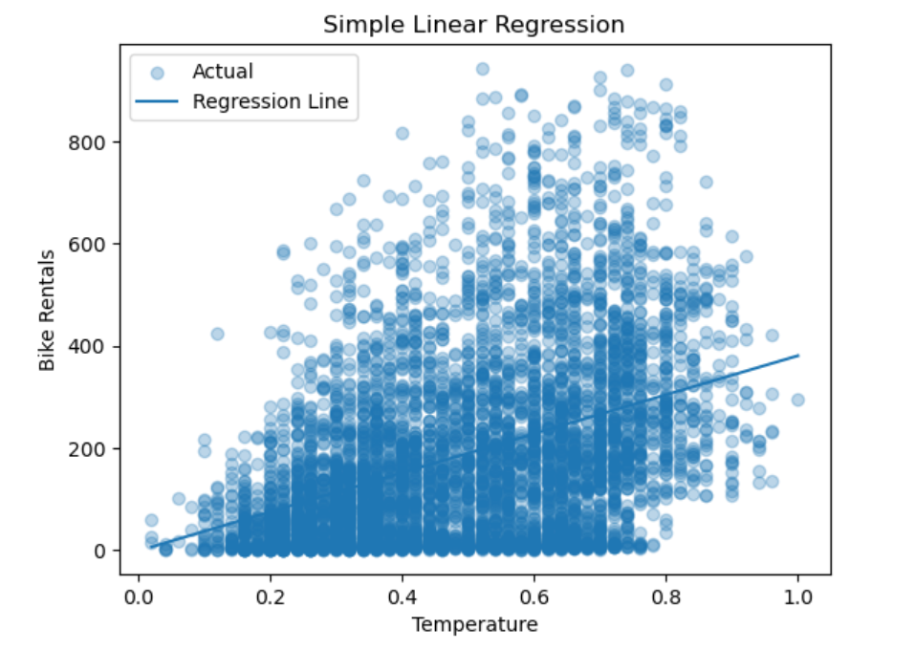
I have calculated both MSE and R-squared-
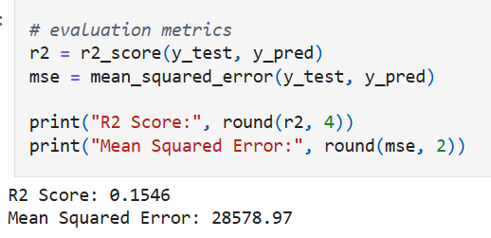

- Observation: The scatter plot showed a clear positive trend — higher temperatures generally led to more rentals. The R-squared value was modest, indicating temperature alone explains part of the variation but not all.

Task 2: Multiple Linear Regression
- Step 1: Extended model with additional features like atemp, hum, and windspeed.
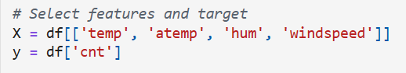
- Step 2: Trained multiple regression model and predicted rentals.
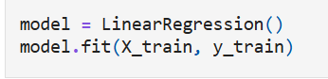
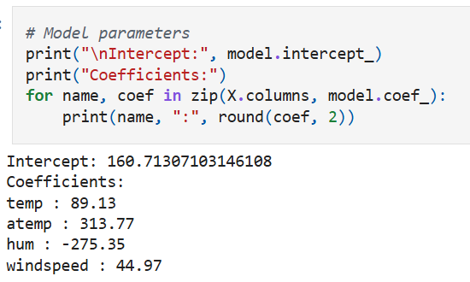
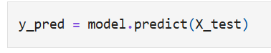
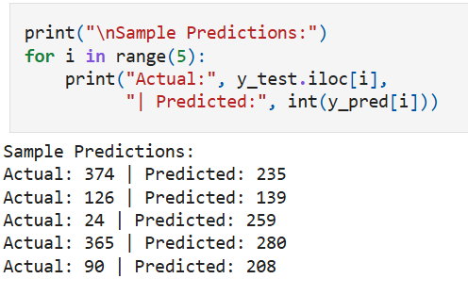
- Step 3: Evaluated performance using Mean Squared Error (MSE) and residual plots.
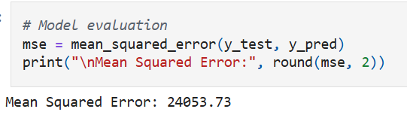
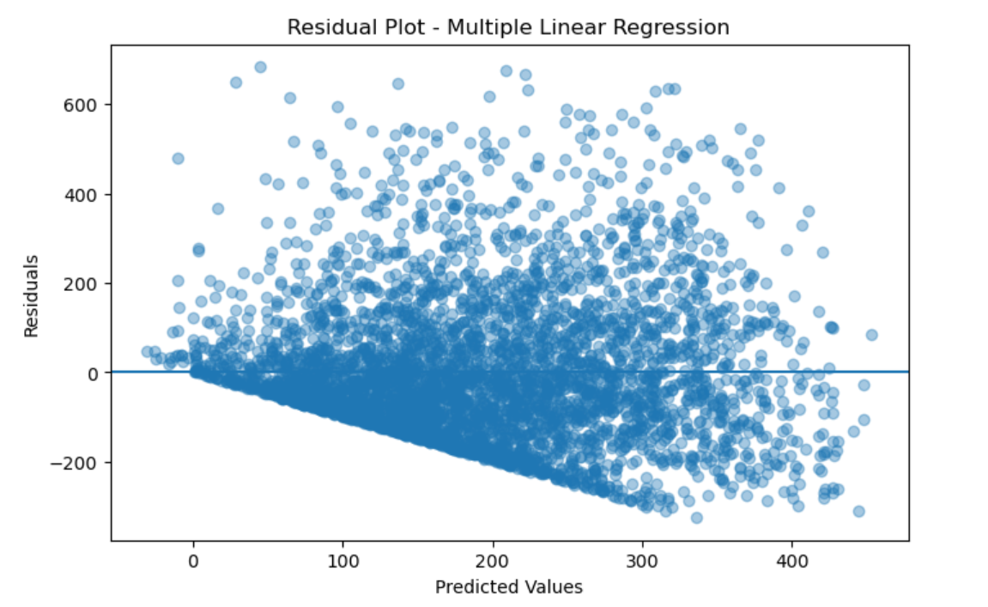
- Observation: Adding more features improved accuracy compared to the simple model. Residual plots showed reduced bias, though some variance remained unexplained.
Task 3: Non-Linear Regression
- Step 1: Create a polynomial feature (’temp2’) by squaring the ’temp’ variable.
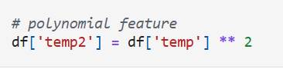
- Step 2: Fit a nonlinear regression model using both ’temp’ and ’temp2’ as predictors.
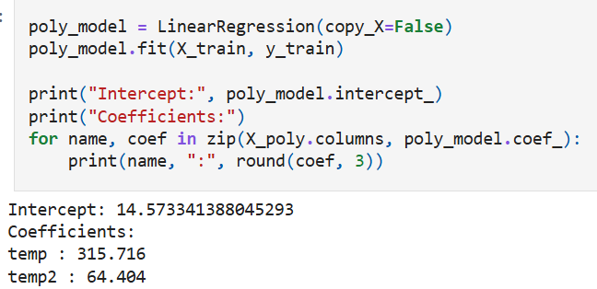
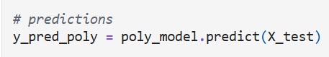

- Step 3: Plot the regression curve and compare the R-squared value with the multiple linear regression model.
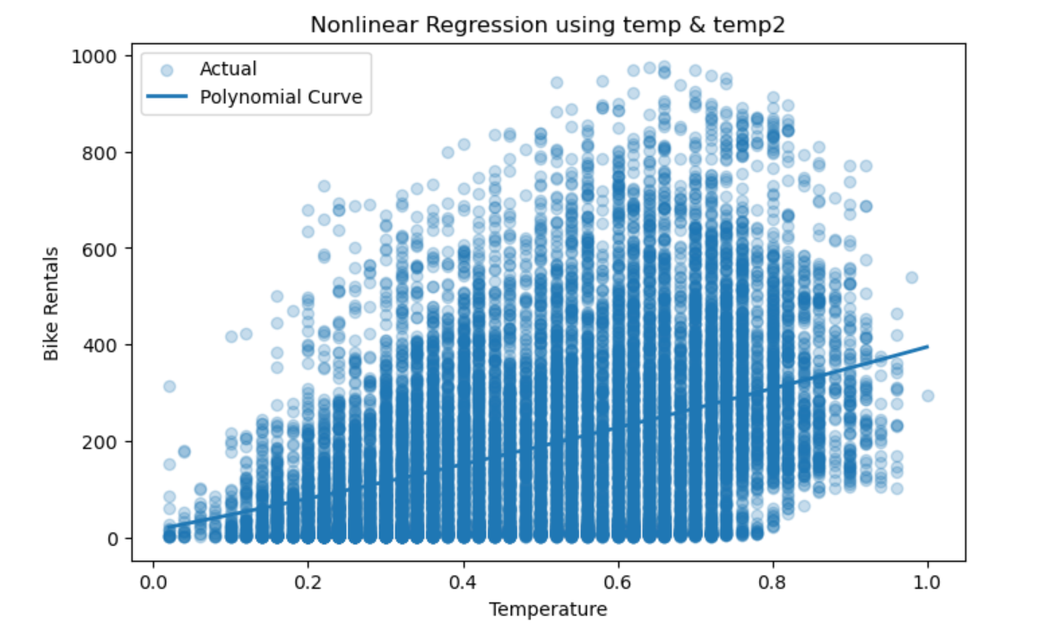
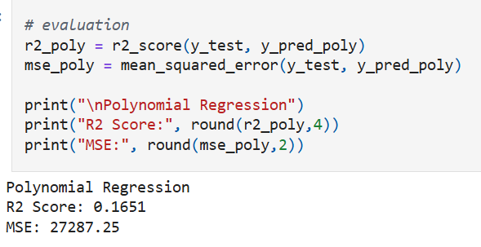
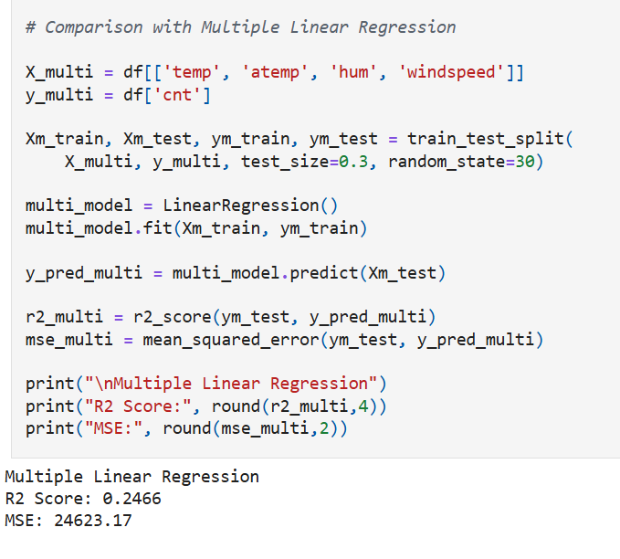

3. Methodology
3.1 Dataset
- Source: https://archive.ics.uci.edu/ml/datasets/Bike+Sharing+Dataset
- Features: Temperature, apparent temperature, humidity, windspeed, weather conditions.
- Target: Rental count (cnt).
3.2 Preprocessing
- Loaded dataset into Pandas.
- Checked for missing values and scaled features where necessary.
- Conducted exploratory data analysis (EDA) with scatter plots and histograms.
3.3 Model Implementation
- Simple Linear Regression: Predictor = temp.
- Multiple Linear Regression: Predictors = temp, atemp, hum, windspeed.
- Polynomial Regression: Predictors = temp, temp2.

4. Results and Discussion
4.1 Simple Linear Regression
- Positive correlation between temperature and rentals.
- R-squared value showed limited explanatory power.
4.2 Multiple Linear Regression
- Improved performance compared to simple regression.
- MSE decreased, residuals more evenly distributed.
4.3 Nonlinear Regression
- Polynomial regression provided the best fit.
- Higher R-squared compared to both linear models.
- Demonstrated that demand patterns are not strictly linear.

5. Conclusion
In this project, we compared the performance of linear, multiple linear, and nonlinear regression models for predicting bike rental demand.
The nonlinear model provided the best fit, suggesting that temperature alone is not sufficient to capture the demand patterns.

